Down Syndrome Centre Odd Sock Training
The Down Syndrome Centre are running an Odd Sock Training campaign running from March 20th until March 27th
The idea is for players to train in Odd Socks, donate to the Down Syndrome Centre via text (DSC to 50300 for a €4 donation) or QR/link code (below) and tag #DSCOddSockTraining on social media to raise awareness
The Down Syndrome Centre, based in Sandyford, support over 400 families. We supply services such as Occupational Therapy, Speech and Language, Physiotherapy and others
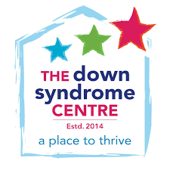
https://downsyndromecentre.enthuse.com/oddsocktraining#!/

